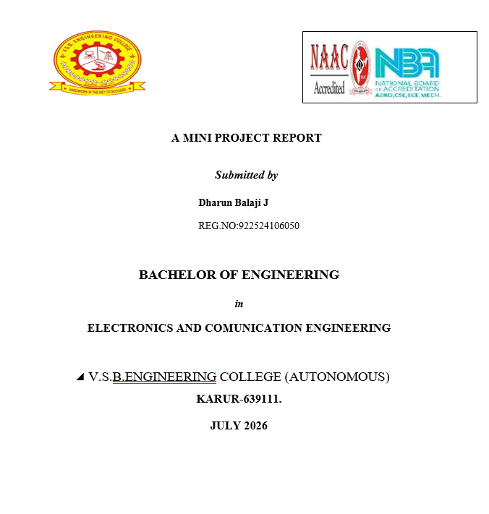
V.S.B.ENGINEERING COLLEGE (AUTONOMOUS)
KARUR-639111.

BONAFIDE CERTIFICATE

Certified that this project report’’ AI powered Personal Farming Assistant ‘’ is the bonafide work of ‘’ Dharun Balaji .J ‘’ Reg.no(922524106050) who carried out the project work under my supervison.

Signature of the faculty signature of the HOD

AI-Powered Personal Farming Assistant

ABSTRACT

- Agriculture is the backbone of many developing countries and plays a vital role in ensuring food security, economic development, and employment generation.
- In India, more than half of the population depends directly or indirectly on agriculture for their livelihood.
- Artificial Intelligence (AI) has emerged as one of the most promising technologies capable of transforming conventional farming into smart farming.
- AI enables computers to learn from historical data, identify patterns, make predictions, and provide recommendations without continuous human intervention.
- These issues often lead to reduced crop productivity, financial losses, and increased uncertainty for farmers.
- Traditional farming methods rely heavily on personal experience and manual observation, which may not always provide accurate or timely solutions.
- Therefore, there is an increasing need for intelligent technologies that can support farmers in making informed decisions throughout the crop cultivation process.

INTRODUCTION
- Agriculture is one of the oldest and most essential occupations in the world, serving as the foundation of human civilization.
- It plays a crucial role in ensuring food security, providing employment opportunities, and contributing significantly to the economic growth of many countries.
- In developing nations such as India, agriculture is considered the backbone of the economy because a large percentage of the population depends on farming for their livelihood.
- Besides supplying food grains, fruits, vegetables, and raw materials for industries, agriculture also supports various sectors including transportation, manufacturing, trade, and exports.
- Despite its importance, the agricultural sector continues to face numerous challenges that affect productivity, profitability, and sustainability.
- The AI-Powered Personal Farming Assistant is proposed as an intelligent digital platform that combines Artificial Intelligence with modern agricultural technologies to assist farmers throughout the entire farming lifecycle.
- The system acts as a virtual agricultural advisor that provides personalized recommendations based on environmental conditions, crop requirements, soil characteristics, weather forecasts, and historical farming data
CONTRIBUTION OF WORK
- The AI-Powered Personal Farming Assistant is developed to provide an intelligent and comprehensive solution for modern agricultural challenges by integrating Artificial Intelligence (AI), Machine Learning (ML), the Internet of Things (IoT), cloud computing, image processing, and Natural Language Processing (NLP).
- Unlike traditional farming systems that rely mainly on manual observation and experience, the proposed system offers real-time monitoring, intelligent decision-making, and personalized recommendations for farmers.
- The project contributes significantly to the field of smart agriculture by improving productivity, reducing resource wastage, enhancing crop quality, and supporting sustainable farming practices.
- The primary contribution of this project is the development of a smart digital farming assistant capable of guiding farmers throughout the entire agricultural lifecycle.
- The assistant acts as a virtual agricultural expert that provides recommendations based on real-time environmental conditions and historical agricultural data.
AI-Based Crop Recommendation System

The proposed system introduces an AI-based crop recommendation module that analyzes multiple agricultural parameters such as:
- Soil type
- Soil pH
- Nitrogen level
- Phosphorus level
- Potassium level
- Temperature
- Rainfall
- Humidity
- Seasonal variations
- Geographical location

Research Work | Technology Used | Advantages | Limitations
AI in Smart Agriculture | AI, Machine Learning | Improves productivity | High computational cost
IoT Smart Farming | IoT Sensors | Real-time monitoring | No intelligent decision-making
Plant Disease Detection | Deep Learning, CNN | High disease detection accuracy | Depends on image quality
Crop Recommendation | Machine Learning | Accurate crop prediction | Limited agricultural services
Precision Agriculture | AI, Big Data | Efficient resource management | High implementation cost
LITERATURE SURVEY
PROPOSED WORK

- To provide intelligent crop recommendations based on soil and weather conditions.
- To monitor soil moisture and optimize irrigation scheduling.
- To detect crop diseases using Artificial Intelligence and image processing.
- To recommend suitable fertilizers based on soil nutrient analysis.
- To predict pest outbreaks before they become severe.
- To integrate real-time weather forecasting for better agricultural planning.
- To provide market price prediction for profitable crop selling.
- To develop an AI-powered multilingual chatbot for farmer assistance.
- To create a responsive web and mobile application.
- To promote precision farming and sustainable agriculture.

SYSTEM WORKFLOW & BLOCK DIAGRAM
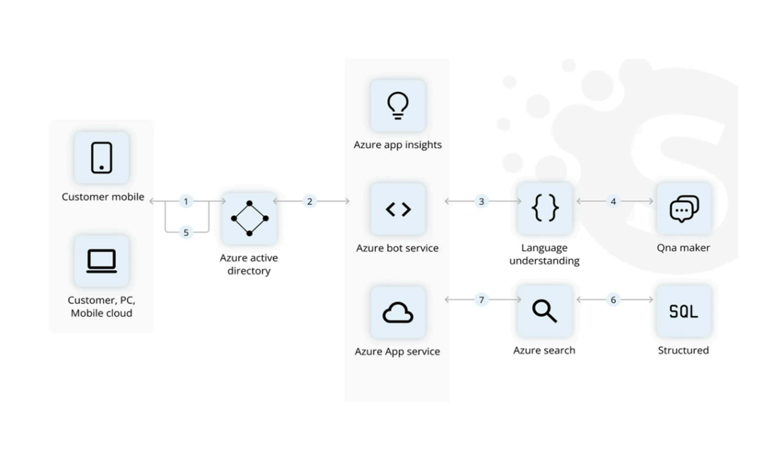
Comparative Analysis of Existing Literature
Research Work | Technology Used | Advantages | Limitations
AI in Smart Agriculture | AI, Machine Learning | Improves productivity | High computational cost
IoT Smart Farming | IoT Sensors | Real-time monitoring | No intelligent decision-making
Plant Disease Detection | Deep Learning, CNN | High disease detection accuracy | Depends on image quality
Crop Recommendation | Machine Learning | Accurate crop prediction | Limited agricultural services
Precision Agriculture | AI, Big Data | Efficient resource management | High implementation cost
Smart Irrigation | IoT | Water conservation | Only irrigation management

PROPOSED SOLUTION
To overcome the limitations of existing systems, the proposed AI-Powered Personal Farming Assistant provides an integrated platform that combines:

- AI-based crop recommendation.
- Soil analysis and fertilizer recommendation.
- Smart irrigation scheduling.
- AI-based crop disease detection.
- Pest prediction.
- Real-time weather forecasting.
- Market price prediction.
- AI-powered multilingual chatbot.
- Cloud-based farm monitoring.
- Mobile and web accessibility.
- Utilize a voice-first.
- Vernacular chatbot (like the Digital Green Farmer,Chat platform).
- Combined with real-time agronomic analytics to deliver hyper-localized crop management, disease diagnosis,etc.

EXPECTED OUTCOME
- Intelligent crop recommendations.
- Accurate soil analysis.
- Smart irrigation management.
- Early disease detection.
- Proper fertilizer recommendations.
- Pest prediction and prevention.
- Real-time weather forecasting.
- Market price prediction.
- AI-powered farming assistance.
- Secure cloud-based farm management.
- Improved crop yield.
- Reduced farming costs.
- Better resource utilization.
- Increased farmer income.
- Promotion of sustainable and precision agriculture.

RESPONSE TIME OF SYSTEM MODULES
Module | Input | Average Response Time
User Login | Username & Password | 0.8 seconds
Dashboard Loading | User Data | 1.2 seconds
Crop Recommendation | Soil & Weather Data | 2.0 seconds
Soil Analysis | Soil Parameters | 1.8 seconds
Weather Forecast | Location | 1.5 seconds
Fertilizer Recommendation | Soil Nutrients | 2.3 seconds
Disease Detection | Crop Image Upload | 3.8 seconds
Pest Prediction | Environmental Data | 2.4 seconds
Market Price Prediction | Crop Details | 2.0 seconds
AI Chatbot Response | User Query | 1.6 seconds
Report Generation | Farm Records | 2.7 seconds

GRAPHICAL COMPARISON
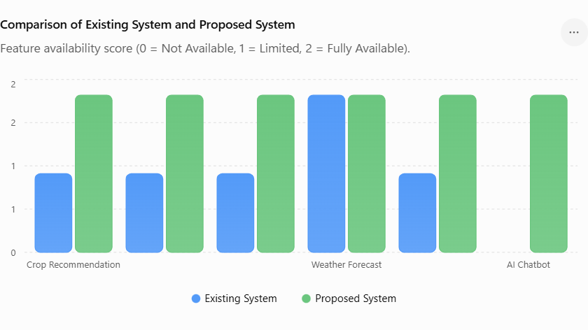
Existing System
The existing agricultural systems mainly provide separate applications for individual farming activities. Some applications offer weather forecasting, while others focus on crop disease detection, irrigation control, or market price information. Most of these systems depend on manual user input and provide only general recommendations rather than personalized guidance.

Limitations of Existing System
- Provides only one or two farming services.
- No complete integration of AI and IoT technologies.
- Limited personalization for different farms.
- Manual monitoring of soil and crop conditions.
- Limited disease detection capability.
- No unified dashboard for farm management.
- Limited or no chatbot assistance.
- Market price prediction is often unavailable.
- Requires multiple applications for different tasks.
- Less efficient resource utilization.

PROPOSED SYSTEM
The proposed AI-Powered Personal Farming Assistant is a comprehensive smart farming platform that integrates multiple AI-based technologies into one application. The system continuously analyzes farm data collected from sensors, weather services, historical datasets, and user inputs to generate personalized recommendations.
Then ;

The proposed system provides:
- AI-based crop recommendation
- Soil health analysis
- Smart irrigation scheduling
- AI-based disease detection
- Fertilizer recommendation
- Pest prediction
- Weather forecasting
- Market price prediction
- AI-powered chatbot
- Cloud-based data storage
- Mobile and web accessibility

Farmer Assistance
Existing farming applications rarely provide continuous support.
The proposed system includes:
A multilingual AI chatbot that answers farmers' questions regarding cultivation, fertilizers, irrigation, pest control, government schemes, and harvesting techniques.
Resource Optimization
Existing systems do not effectively optimize farming resources.
The proposed system reduces:
- Water wastage
- Fertilizer overuse
- Pesticide consumption
- Manual labor

Disease Detection
Most existing applications either lack disease detection or provide only basic identification.
The proposed system uses Deep Learning and image processing to identify plant diseases at an early stage and immediately recommends treatment methods.
Profitability
The proposed system predicts market prices and recommends the best time to sell crops, helping farmers maximize their income—an important feature missing from many existing systems.
Farmer Assistance
The proposed system includes a multilingual AI chatbot that answers farmers' questions regarding cultivation, fertilizers,irrigation, pest control, government schemes, and harvesting techniques.

SYSTEM IMPLEMENTATION RESULTS
The AI-Powered Personal Farming Assistant was developed as a responsive web and mobile application capable of handling multiple agricultural operations. The system was designed with a user-friendly interface so that farmers with different educational backgrounds could easily access its features. Each module was tested individually and then integrated into a complete smart farming platform.
The testing results indicate that the system successfully performs the following operations:
- Farmer registration and secure login.
- Collection of soil and environmental information.
- AI-based crop recommendation.
- Intelligent irrigation scheduling.
- Crop disease detection using image analysis.
- Fertilizer recommendation based on soil nutrients.
- Weather forecasting with alert notifications.
- Pest outbreak prediction.
- Market price analysis and prediction.
- AI chatbot interaction.
DISCUSSION
The implementation of the AI-Powered Personal Farming Assistant shows that the system can effectively support farmers in their daily farming activities. The project combines Artificial Intelligence (AI), Machine Learning (ML), IoT, cloud computing, image processing, and Natural Language Processing (NLP) to provide smart and accurate farming solutions. The system helps farmers make better decisions by analyzing real-time data instead of relying only on traditional farming methods.
The discussion of the project is summarized below:
- The system provides accurate crop recommendations based on soil type, weather conditions, and crop requirements.
- It helps farmers choose the most suitable crop for cultivation, improving productivity.
- The smart irrigation module recommends the right amount of water, reducing water wastage.
- The fertilizer recommendation system suggests the correct fertilizer and quantity based on soil nutrients.
- The AI-based disease detection module identifies plant diseases early using crop images.
- Early disease detection helps farmers take quick action and reduce crop losses.
- The pest prediction module warns farmers about possible pest attacks before they become severe.
- The weather forecasting module provides real-time weather updates and alerts for better farming planning.
- The market price prediction feature helps farmers decide the best time to sell their crops and earn better profits.
- The AI chatbot provides instant answers to farming-related questions at any time.
- The system stores farming records securely using cloud storage, making data easy to access whenever needed.
- The web and mobile applications are simple, user-friendly, and easy to use for farmers.
- The integrated platform reduces the need to use multiple applications for different farming activities.
- AI-based recommendations help reduce unnecessary use of water, fertilizers, and pesticides.
- The system supports precision farming and promotes sustainable agricultural practices.
- Farmers can make faster and more informed decisions using real-time information.
PROJECT OBJECTIVES

- To design and develop an AI-Powered Personal Farming Assistant that helps farmers make better farming decisions using Artificial Intelligence (AI), Machine Learning (ML), Internet of Things (IoT), cloud computing, and image processing technologies.
- To provide intelligent crop recommendations by analyzing soil type, weather conditions, temperature, humidity, rainfall, and nutrient levels so that farmers can select the most suitable crop for cultivation.
- To assist farmers in improving agricultural productivity by providing accurate and data-driven recommendations throughout the farming lifecycle.
- To analyze soil conditions, including soil moisture, pH value, nitrogen, phosphorus, and potassium levels, and recommend suitable measures to improve soil fertility.
- To develop a smart irrigation management system that recommends the appropriate amount of water and irrigation schedule based on soil moisture and weather conditions.
- To reduce unnecessary water consumption by encouraging efficient irrigation practices and promoting water conservation.
- To detect crop diseases at an early stage using Artificial Intelligence and image processing techniques by analyzing images of plant leaves uploaded by farmers.
- To recommend suitable treatments, pesticides, and preventive measures after identifying crop diseases in order to reduce crop losses.
- To provide fertilizer recommendations based on soil nutrient analysis and crop requirements, ensuring balanced fertilizer application and reducing unnecessary fertilizer usage.
- To predict possible pest attacks by analyzing environmental conditions and historical farming data, allowing farmers to take preventive actions before pest infestations become severe.
- To integrate real-time weather forecasting services that provide information such as temperature, rainfall, humidity, wind speed, and weather alerts for better agricultural planning.
- To notify farmers about adverse weather conditions so they can schedule irrigation, fertilizer application, pesticide spraying, and harvesting at the appropriate time.
- To predict future market prices of agricultural products using Artificial Intelligence so that farmers can identify the best time to sell their crops and maximize their profits.

PROJECT SPECIFICATION
- Provides accurate crop recommendations.
- Detects crop diseases at an early stage.
- Reduces water wastage through smart irrigation.
- Improves fertilizer management.
- Predicts pest attacks before crop damage occurs.
- Provides real-time weather information.
- Estimates future market prices.
- Responds to user requests within a few seconds.
- Stores agricultural records securely. .
- Improves agricultural productivity and crop quality.
- Reduces farming costs.
- Increases farmers' income.
- Promotes sustainable and precision farming.
- Provides a complete digital farming solution through a single platform.
- Responsive web and mobile application.
- Soil analysis module that evaluates soil fertility.
- System provides fertilizer recommendations according to crop type.
- Provides real-time weather forecasting including temperature, rainfall, humidity, wind speed.
  - predicts future market prices to help farmers sell crops.

CONCLUSION

- The AI-Powered Personal Farming Assistant is a smart and user-friendly solution for modern agriculture.
- It uses Artificial Intelligence (AI), Machine Learning (ML), IoT, cloud computing, and image processing to support farmers.
- The system provides crop recommendation, soil analysis, smart irrigation, disease detection, fertilizer recommendation, weather forecasting, pest prediction, and market price prediction in one platform.
- It helps farmers make accurate and timely decisions based on real-time data.
- The project reduces water wastage, fertilizer usage, pesticide usage, and overall farming costs.
- It improves crop productivity, crop quality, and farmer income.
- The AI chatbot provides instant guidance and agricultural support to farmers.
- The web and mobile application makes the system easy to access and use.
- The project promotes precision farming and sustainable agricultural practices.
- Overall, the proposed system is a low-cost, efficient, and reliable smart farming solution .
REFERENCES
- Food and Agriculture Organization (FAO)
- Ministry of Agriculture & Farmers Welfare, Government of India
- IBM Agriculture Solutions
- TensorFlow Documentation
- Scikit-learn Documentation
- Arduino Official Website
- Raspberry Pi Foundation
- OpenWeather Weather API
- Kaggle Agricultural Datasets
- J. Han, M. Kamber, and J. Pei, Data Mining: Concepts and Techniques,Morgan Kaufmann Publishers.
- S. Russell and P. Norvig, Artificial Intelligence: A Modern Approach,Pearson Education.
- Research papers on AI, IoT, and Smart Agriculture from the digital library
- of the Institute of Electrical and Electronics Engineers (IEEE)

EXPECTED OUTCOME
- Intelligent crop recommendations.
- Accurate soil analysis.
- Smart irrigation management.
- Early disease detection.
- Proper fertilizer recommendations.
- Pest prediction and prevention.
- Real-time weather forecasting.
- Market price prediction.
- AI-powered farming assistance.
- Secure cloud-based farm management.
- Improved crop yield.
- Reduced farming costs.
- Better resource utilization.
- Increased farmer income.
- Promotion of sustainable and precision agriculture.

